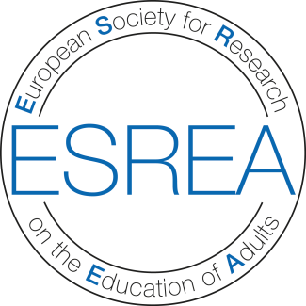

Presentation
The European Society for Research on the Education of Adults (ESREA) is a non-profit research association devoted to advancement of high-quality research on the education and learning of adults in Europe.
The society supports: 1) co-operation among researchers; 2) development of research and dissemination of results (e.g. through conferences, a book series, and The European Journal for Research on the Education and Learning of Adults - RELA); 3) training of early career researchers (e.g. through winter/summer schools), and continuing professional development of researchers; and 4) collaboration with other European organisations and national organisations working in all areas of adult and continuing education.
ESREA’s main activities are conferences and seminars organised by its 13 research networks, and the ESREA triennial conference, one of the key moments in the organisation’s life for members (and non members) to meet across networks and engage in cross-network conversations.
ESREA is a membership organisation. Membership is open to individuals and institutions engaged or interested in research on the education of adults and adult learning from Europe and beyond. Benefits include: 1) reduced registration fees to all ESREA and networks conferences, 2) several newsletters each year, and 3) emails about news in the field (publications, calls for papers, job offers, etc.). Moreover, PhD student members may benefit from a limited number of bursaries available to support their participation at conferences, and the award of a prize for the best paper presented by a PhD student at each triennial conference.
Membership fees constitute the main means for ESREA to pursue its mission. Its Presidium members and all convenors of its research networks serve the society on a voluntary basis.

